**PROJECT PLANNING PHASE**

**Sprint Delivery Plan**

|  |  |
| --- | --- |
| TEAM ID | PNT2022TMID13519 |
| PROJECT NAME | Real-Time River Water Quality Monitoring and  Control System |
| MAXIMUM MARKS | 8 MARKS |

**Product Backlog, Sprint Schedule, and Estimation (4 Marks)**

Use the below template to create product backlog and sprint schedule

|  |  |  |  |  |  |  |
| --- | --- | --- | --- | --- | --- | --- |
| **Sprint** | **Functional**  **Requirement(Epic)** | **User**  **Story**  **Number** | **User**  **Story/Task** | **Story Points** | **Priority** | **Team Members** |
| Sprint 1 | Registration | USN-1 | As a user, I can register for the application by entering my email, password, and confirming my password. | 2 | High | S.Keerthana |
| Sprint-1 |  | USN-2 | As a user, I will receive confirmation email once I have registered for the application | 1 | High | S.Bharathi |
| Sprint-2 |  | USN-3 | As a user, I can register for the application through Facebook | 2 | High | R.Deepika |
| Sprint-1 |  | USN-4 | As a user, I can register for the application through Gmail | 2 | Medium | M.Dharshini |

**Project Tracker, Velocity & Burndown Charts (4 Marks):**

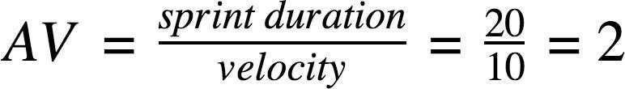

**Burndown Chart:**

